**Wireframe Document**

**NEWS ARTICLES SORTING**

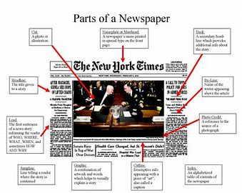

**Revision Number - 1.0**

**Last Date of Revision – 03/04/2024**

# Document Version Control

|  |  |  |  |
| --- | --- | --- | --- |
| **Date Issued** | **Version** | **Description** | **Author** |
| 03/04/2024 | 1.0 | HLD Document | Prajwal Sarode |

**Name : Prajwal Sarode**

**Email : prajwal.sarode@outlook.com**

**iNeuron Internship Project**

